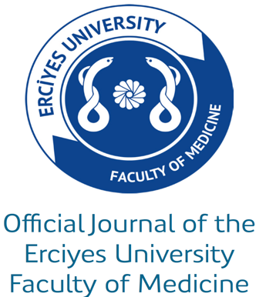

JOIN THE JOURNAL OF CLINICAL PRACTICE AND RESEARCH

The editorial board is one measure of the quality of a journal. Members provide critical guidance and act as ambassadors for the journal. The position includes both benefits and responsibilities. It is important to regularly recruit new members and we encourage qualified candidates to consider applying for membership to the editorial board.

JOURNAL OF CLINICAL PRACTICE AND RESEARCH

Journal of Clinical Practice and Research (J Clin Pract Res) is an international, peer-reviewed, open- access journal. Six issues are published per year. The publication language of the journal is English.
Editor roles and responsibilities Editors of Journal of Clinical Practice and Research are responsible for assessing the scope and quality of each manuscript submitted and making a recommendation based on the peer-review results. One the most important tasks is to decide whether a manuscript merits publication in Journal of Clinical Practice and Research. The editorial board is collectively responsible for ensuring that the journal publishes high-quality research.

Criteria for becoming an editorial board member
- Credentialed expertise in a relevant subject
- A strong record of peer-reviewed publications
- Eagerness to contribute ideas and expertise to help shape journal goals, policies, and development
- Sufficient level of English to manage article evaluation and correspondence
- Ability to evaluate at least 20 articles per year with adequate time to oversee peer review of a manuscript through to a final decision
If you would like to join the editorial board of Journal of Clinical Practice and Research, please complete this form and send it by e-mail to: erciyesmedj@gmail.com.

APPLICATION TO JOIN THE EDITORIAL BOARD OF JOURNAL OF CLINICAL PRACTICE AND RESEARCH

First Name:
Last Name:
ORCID ID:
H index (Web of Science):
Email:
Institutional affiliation(s):
Position: (Please provide a link to institutional
and/or personal websites, as appropriate)
Briefly describe your area(s) of scientific expertise and/or the focus of your current research (1-2 sentences):
Specialty:
Highest degree (or equivalent):
Year of degree completion:
Approximate number of peer-reviewed research articles published in English, you have authored in your career?
Are you interested in reviewing manuscripts reporting the results of clinical trials? (Prior clinical trial experience required)
- Yes
- No
Please upload your CV, and include any prior or current editorial board experience.

